**TÜV Rheinland presents traceability testing service for photovoltaic modules**

Project-specific service for large-scale PV projects / Traceability of supply chain documentation / Based on globally recognized management standard ISO 9001 / For investors, project developers and purchasers / [www.tuv.com/solar](http://www.tuv.com/solar)

TÜV Rheinland, one of the world's leading testing and certification companies, is presenting its Traceability Service for Photovoltaic Modules at Intersolar, booth A5.374. This service helps project developers, purchasers or investors to trace the documentation of the supply chain of their purchased PV modules on a project-by-project basis. The traceability testing service is based on the globally recognized ISO 9001 management system standard. In addition, TÜV Rheinland takes into account other individual customer requirements that may vary from project to project. The Traceability Testing Service contributes to greater quality assurance and transparency in the photovoltaic (PV) industry.

**Special features of the traceability service**

Maximilian Lieberz, Business Development Manager at TÜV Rheinland: "TÜV Rheinland's traceability service takes a look at the documentation of the entire PV module supply chain. We look at whether and to what level of detail the systems, tools and processes used by manufacturers are able to ensure traceability. On this basis, purchasers of photovoltaic modules can also improve their quality assurance in a sustainable way.

Therefore, TÜV Rheinland follows a three-step approach. The first stage is based on ISO 9001 and any other project-specific requirements of the customer. In the second step, TÜV Rheinland examines the existing management processes and the tools used for traceability. On this basis, TÜV Rheinland also analyses, for example, whether a manufacturer can cope with potentially stricter traceability requirements in the future. In the third step, TÜV Rheinland looks at the entire traceability chain and determines the level of detail to which manufacturers can document traceability.

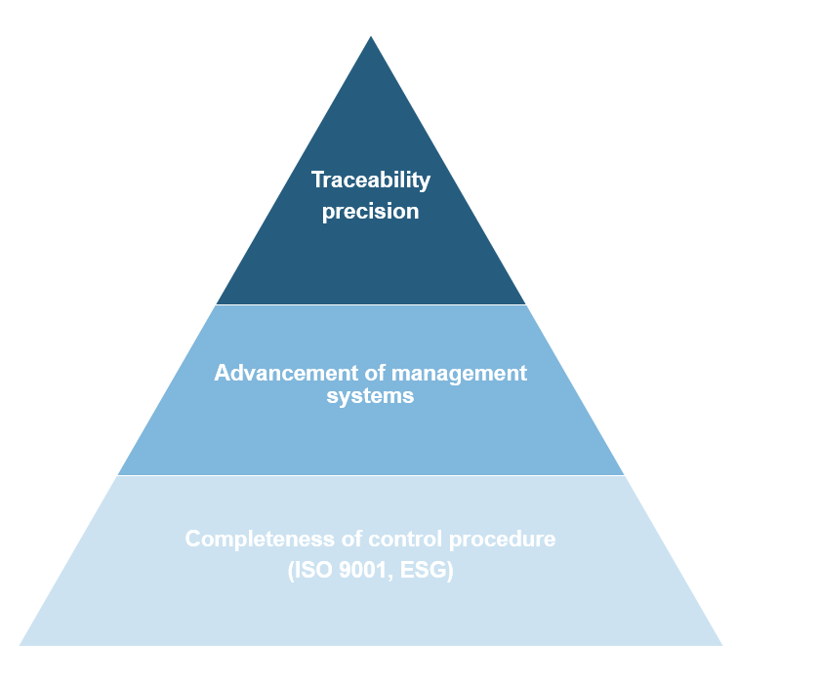

**Principle of TÜV Rheinland's Traceability Service for PV Modules**

The background to TÜV Rheinland's new service is the rapid development of the PV industry and the increasing global importance of ESG issues, including traceability.

To develop the service, TÜV Rheinland experts audited more than 70 factories from seven of the world's ten largest PV module manufacturers in Asia for traceability in 2023 and 2024.

TÜV Rheinland offers this service worldwide. The aim is not only to provide an individual service for buyers and investors in PV projects, but also to establish the requirements for traceability management as a standard in the PV industry. Interested parties can contact: [pv.supply.chain@tuv.com](mailto:pv.supply.chain@tuv.com)

*Safety and quality in almost all areas of business and life: That’s what TÜV Rheinland stands for. The company has been active for more than 150 years and is one of the world’s leading testing service providers. TÜV Rheinland has more than 22,000 employees in over 50 countries and generates annual sales of more than 2.4 billion euros. TÜV Rheinland’s highly qualified experts test technical systems and products around the globe, accompany innovations in technology and business, train people in numerous professions and certify management systems according to international standards. In this way, the independent experts ensure trust along global flows of goods and value chains. Since 2006, TÜV Rheinland has been a member of the United Nations Global Compact for more sustainability and against corruption. Website:* [*www.tuv.com*](http://www.tuv.com)

__________________________________________________________________

Media contact:

TÜV Rheinland, Press Office, Tel.: +49 221 806-21 48

Press releases as well as photo and video footage are available on request by email to contact@press.tuv.com or on www.tuv.com/press.