TÜV Rheinland acquires specialist inspection and verification company Inspection Verification Bureau Ltd (IVB)

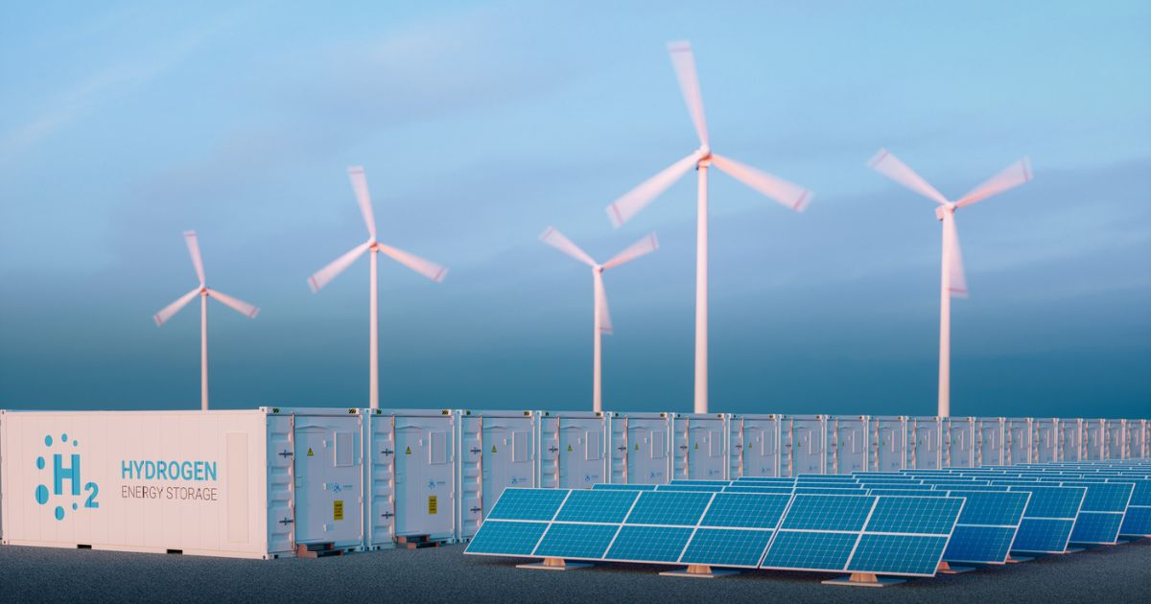

Nov 2, 2022 | Company, Industry & Digitalization

Independent inspection and verification services in the energy sector / Strategic growth in voluntary inspection services

Your contact for editorial questions:

**Press Office TÜV Rheinland**, Tel.: +49 2 21/8 06-21 48

You can also obtain the latest press releases as well as topic-related photos and videos by e-mail via presse@de.tuv.com and on the Internet: presse.tuv.com and www.twitter.com/tuvcom_presse

TÜV Rheinland successfully completed the acquisition of inspection company Inspection Verification Bureau Ltd (IVB) on October 13, 2022. IVB will continue to operate as a separate legal entity until December 31, 2023, after which it will be fully integrated into TÜV Rheinland UK Ltd.

“IVB provides independent and specialist inspection and verification services to the global oil, gas, renewable energy and power industries. The acquisition strengthens TÜV Rheinland's position as a full-service provider to the industry with complimentary services, particularly in the voluntary inspection services sector in the UK market”, said Gareth Book of TÜV Rheinland.

For the current shareholders of IVB, TÜV Rheinland is a very good and well-known partner, as they have been working together for many years. “TÜV Rheinland has a structural interest in the business activities of IVB, has a strong brand and wants to further expand and protect the supply of IVB’s inspection and verification services and resources for other parts of the TÜV Rheinland group. This was very important to us,” says Matthew Chapman, one of IVB's managing partners. Christopher Bolton, also a managing partner of IVB, adds: “We are pleased that the jobs are secured for the employees of IVB, some of whom have been working with us since IVB was founded. Furthermore, many new development opportunities are opening up.” Founded in 2010, the company has a small, experienced team based in Great Yarmouth, England, supported by an extensive network of highly skilled engineers.

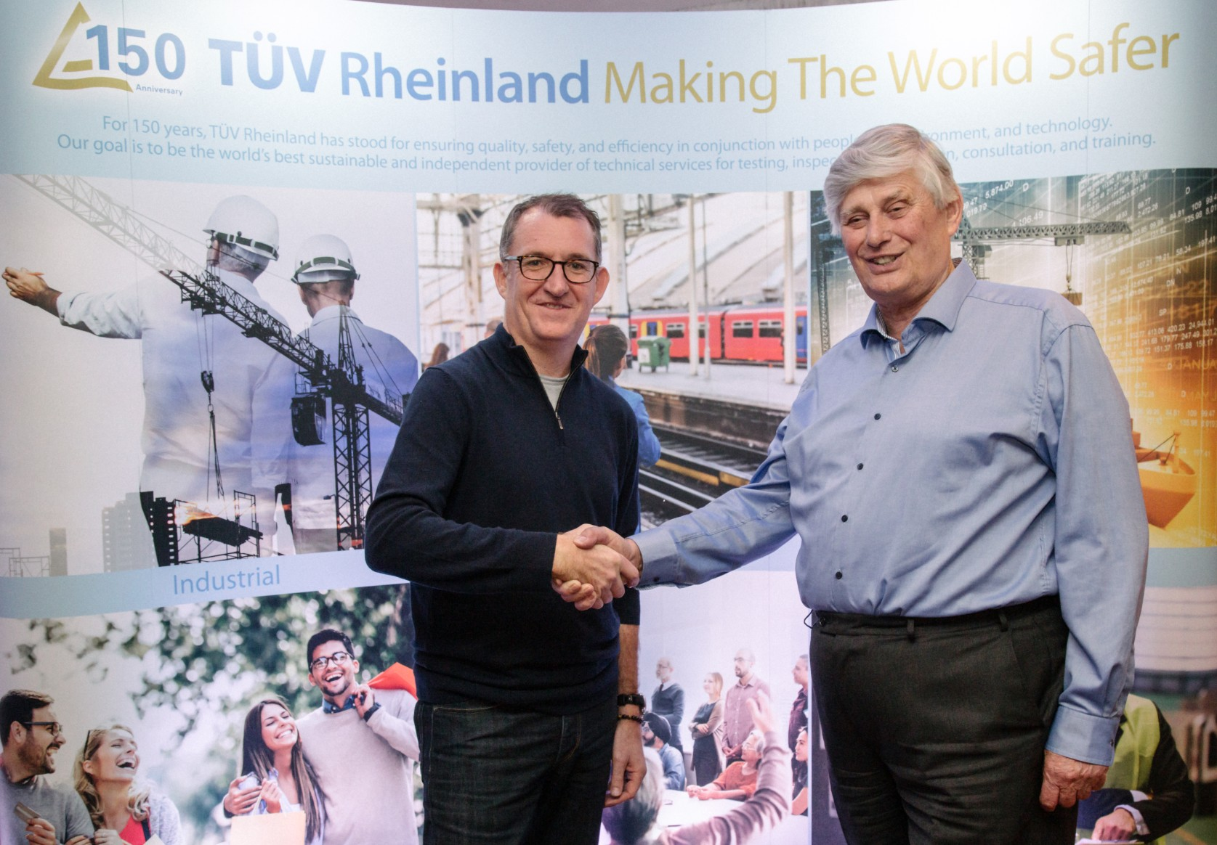  
Gareth Book (TÜV Rheinland) and Chris Bolton (IVB Ltd) are pleased with the merger.

150 years of safety: Since 1872, TÜV Rheinland’s mission has been to make technology safe for people and the environment. From the steam engine to digitalization, the erstwhile “Verein zur Überwachung der Dampfkessel in den Kreisen Elberfeld und Barmen” (Association for the Inspection of Steam Boilers in the Districts of Elberfeld and Barmen) has evolved into a global testing service provider ensuring safety and quality in virtually all areas of business and life. This responsibility is now shared by more than 20,000 employees, who generate annual revenues of around EUR 2.1 billion. Around the globe, experts from TÜV Rheinland test technical systems and products, support innovations in technology and industry, train personnel in a wide range of professions, and certify management systems according to international standards. With safety and sustainability, TÜV Rheinland is also shaping the future. Since 2006, TÜV Rheinland has therefore been a member of the United Nations Global Compact to promote sustainability and combat corruption. Website: [www.tuv.com](https://www.tuv.com/)