TÜV Rheinland: MATTER 1.0 - Trend-setting standard for smart home devices

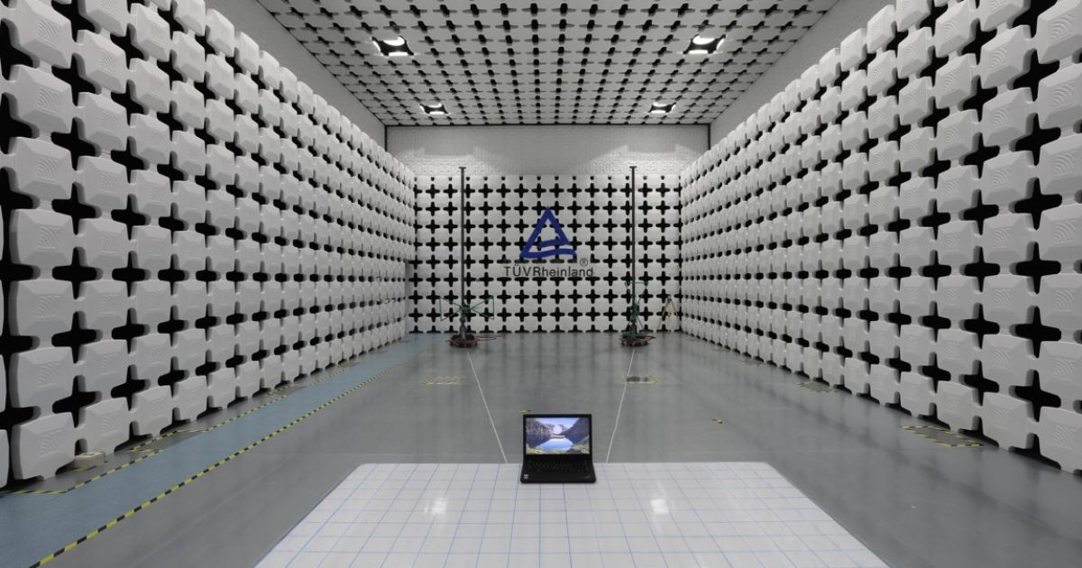

Oct 31, 2022 | Industry & Digitalization

Unified testing standard for billions of devices worldwide: Better connectivity / Less power consumption / More data protection / Cross-brand and cross-platform functionality

Your contact for editorial questions:

**Press Office TÜV Rheinland**, Tel.: +49 2 21/8 06-21 48

You can also obtain the latest press releases as well as topic-related photos and videos by e-mail via presse@de.tuv.com and on the Internet: presse.tuv.com and www.twitter.com/tuvcom_presse

TÜV Rheinland now offers testing and certification for smart home products according to the MATTER communication standard of the “Connectivity Standards Alliance:. MATTER is the first international standard that defines uniform, cross-national framework conditions for smart home products.

"Users want intuitive device operation with maximum functionality and performance," explains Lourens Koopmans, senior expert for wireless technologies, from TÜV Rheinland. "In addition, the devices should not only function in a specific smart home system, but should be able to communicate with each other in different systems. MATTER harmonizes the different technical and legal country-specific features in a standardized protocol."

**Better products thanks to uniform international standards**  
As a result, developers attest MATTER-certified products improved connectivity and interoperability - regardless of brand or platform. In addition, special technology standards ensure significantly more efficient and thus more power-saving device operation. MATTER operates over Ethernet, Wi-Fi and Thread, and uses Bluetooth low-energy to connect devices. MATTER 1.0-certified devices will also have an easier time with data protection in the future.

**5-year forecast: half of all devices to comply with MATTER standard**   
According to technology company ABI Research, more than half of all smart home devices will ship with Matter support within five years. TÜV Rheinland has four of 18 laboratories worldwide, where both new and existing smart home products can now be tested for MATTER 1.0 criteria such as connectivity, performance and interoperability. "We know the different conditions, technical standards and certifications in more than 180 countries," continues Koopmans. "Our experts carry out a wide range of tests and check conformity and documentation regulations in the respective region. This enables manufacturers to enter the market faster and more securely."

TÜV Rheinland offers MATTER 1.0 testing and certification to its customers worldwide through one of four CSA authorized laboratories in Lund, Sweden; Seoul, Korea; Yokohama, Japan; and Shenzhen. China.

**Background**  
More than 18 billion smart home devices are in use worldwide. Experts estimate that this figure will rise to 27 billion by 2027: from smart light bulbs and intelligent vacuum cleaners to parking lot monitoring systems for municipalities. However, the national requirements and regulations for smart homes are just as varied as their areas of application. As a result, manufacturers or retailers are faced with import and sales difficulties - and consumers with corresponding losses in the performance of devices.

With MATTER 1.0, the Connectivity Standards Alliance's (CSA) project consortium with a total of more than 550 involved and internationally active technology companies has now developed a protocol that defines standardized, cross-national requirements and framework conditions for smart home products.

More information under the following [link](https://www.tuv.com/landingpage/en/wireless/?wt_mc=Press.Press-Release.no-interface.CW20_X00_WRL.CW20_X00_WRL01_PR_01.shortcut.WirelessShortcut&cpid=CW20_X00_WRL01_PR_01).

Related Videos:

* [Testing & Certification for IoT](https://youtu.be/tbjHVoOvAWM)
* W[ireless Product Certification Challenges](https://youtu.be/G-bv2DDDarM)

150 years of safety: Since 1872, TÜV Rheinland’s mission has been to make technology safe for people and the environment. From the steam engine to digitalization, the erstwhile “Verein zur Überwachung der Dampfkessel in den Kreisen Elberfeld und Barmen” (Association for the Inspection of Steam Boilers in the Districts of Elberfeld and Barmen) has evolved into a global testing service provider ensuring safety and quality in virtually all areas of business and life. This responsibility is now shared by more than 20,000 employees, who generate annual revenues of around EUR 2.1 billion. Around the globe, experts from TÜV Rheinland test technical systems and products, support innovations in technology and industry, train personnel in a wide range of professions, and certify management systems according to international standards. With safety and sustainability, TÜV Rheinland is also shaping the future. Since 2006, TÜV Rheinland has therefore been a member of the United Nations Global Compact to promote sustainability and combat corruption. Website: [www.tuv.com](https://www.tuv.com/)