New TÜV Rheinland certification: boost for building-integrated photovoltaics

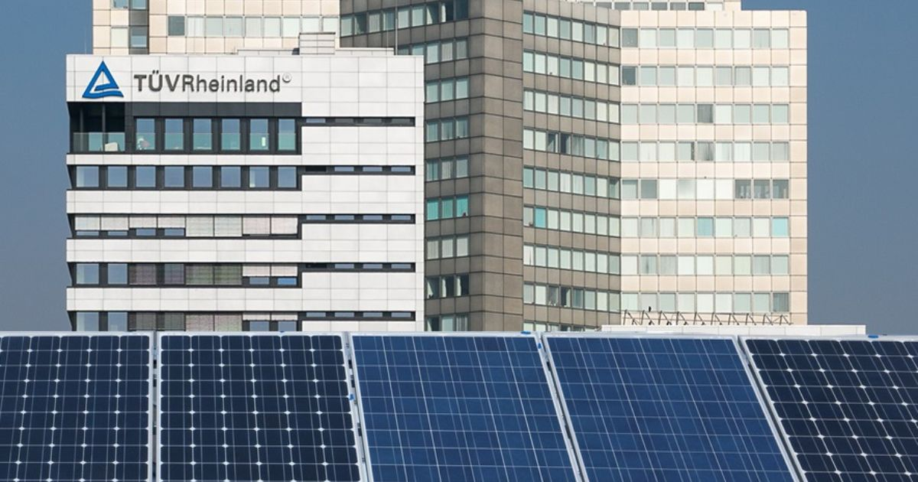

Nov 15, 2022 | Industry & Digitalization

TÜV Rheinland further expands service portfolio for sustainability / Globally unique certification for high safety and quality standards for building-integrated photovoltaic (BIPV) modules / Paving the way for building authority approvals / Added value for dealers, manufacturers and buyers of photovoltaic systems

Your contact for editorial questions:

**Press Office TÜV Rheinland**, Tel.: +49 2 21/8 06-21 48

You can also obtain the latest press releases as well as topic-related photos and videos by e-mail via presse@de.tuv.com and on the Internet: presse.tuv.com and www.twitter.com/tuvcom_presse

TÜV Rheinland has launched a globally unique test standard (2 PfG 2796/02.22) for the certification of building-integrated photovoltaic modules (BIPV). This paves the way for the tests and qualifications required before BIPV systems can be put into operation, including preparations for approval by the building authorities. So far, there has not yet been a test standard for BIPV systems that certifies their compliance with uniform safety and quality standards. The result: intransparency and quality deficiencies as well as associated uncertainties in the BIPV market.

"The new TÜV Rheinland certification offers a solution for subjecting building-integrated photovoltaic modules to an independent and standardized testing and quality assurance procedure even before they are sold," explains Lukas Jakisch, Segment Manager at TÜV Rheinland. TÜV Rheinland's experts examine properties of the photovoltaic modules that are relevant to both building requirements and electrotechnical requirements. They take into account both the European Construction Product Regulation CPR 305/2011 and the Low Voltage Directive 2014/35/EU, as well as [CENELEC Standards](https://www.dke.de/en/about-us/the-dke-organization/external-relations-and-support). "TÜV Rheinland is a market leader in the certification of PV products and systems," he said. "Our customers can rely on certified products meeting the most stringent quality and safety testing requirements," says PV expert Lukas Jakisch.

Background: current BIPV standards (EN 50583 and IEC 63092) are not mandatory product certification. However, they serve as a technical basis for the development of the 2 PfG 2796 TÜV Rheinland standard. This provides the requirements for qualification and certification of BIPV modules in order to strengthen the confidence of distributors, manufacturers and purchasers in their quality through product certification.

More info under the following [Link](https://www.tuv.com/world/en/photovoltaic-modules.html) >>

150 years of safety: Since 1872, TÜV Rheinland’s mission has been to make technology safe for people and the environment. From the steam engine to digitalization, the erstwhile “Verein zur Überwachung der Dampfkessel in den Kreisen Elberfeld und Barmen” (Association for the Inspection of Steam Boilers in the Districts of Elberfeld and Barmen) has evolved into a global testing service provider ensuring safety and quality in virtually all areas of business and life. This responsibility is now shared by more than 20,000 employees, who generate annual revenues of around EUR 2.1 billion. Around the globe, experts from TÜV Rheinland test technical systems and products, support innovations in technology and industry, train personnel in a wide range of professions, and certify management systems according to international standards. With safety and sustainability, TÜV Rheinland is also shaping the future. Since 2006, TÜV Rheinland has therefore been a member of the United Nations Global Compact to promote sustainability and combat corruption. Website: [www.tuv.com](https://www.tuv.com/)