TÜV Rheinland certifies world’s first unmanned aircraft system under new EU drone regulation

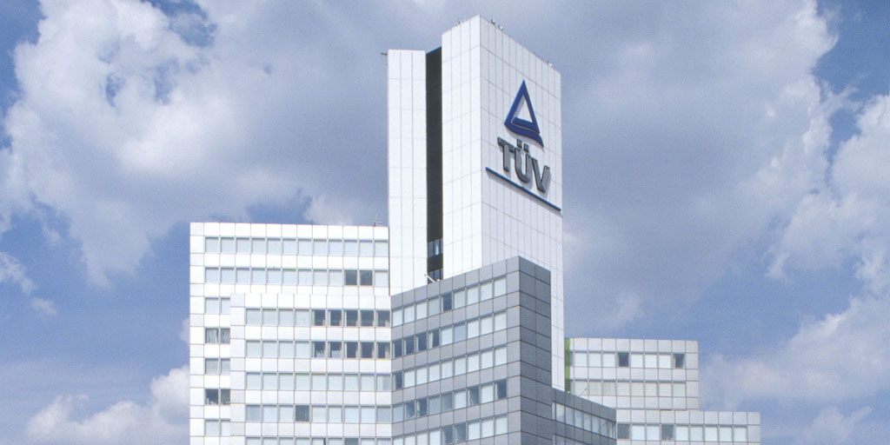

*TÜV Rheinland has granted the world's first certification for a drone in accordance with the new EU regulation for civil unmanned aircraft systems (UAS) as an official Notified Body.*

Aug 18, 2022 | Consumers & Product Safety, Industry & Digitalization

Camera drone from DJI granted certification / Advantages of flying with certified Class C1 drones / First certification from TÜV Rheinland for an unmanned aircraft system.

Your contact for editorial questions:

**Press Office TÜV Rheinland**, Tel.: +49 2 21/8 06-21 48

You can also obtain the latest press releases as well as topic-related photos and videos by e-mail via presse@de.tuv.com and on the Internet: presse.tuv.com and www.twitter.com/tuvcom_presse

TÜV Rheinland has granted the world’s first certification for a drone in accordance with the new EU regulation for civil unmanned aircraft systems (UAS). Experts from the international testing service provider comprehensively tested the Mavic 3 system from manufacturer DJI for compliance with the drone class C1 requirements of the new regulation (EU) 2019/945. The scope of the so-called EU type examination in the laboratories of TÜV Rheinland included features such as mechanical strength, safe controllability in a wide range of flight and operating conditions, and compliance with the sound power level and thus the volume on the device of a maximum of 83 decibels. To be certified, Class C1 systems must also have, among other things, a remote identification system and a reliable data link as well as a data interface for a geo-awareness system to comply with airspace limitations.

“TÜV Rheinland is an official Notified Body allowed to certify unmanned aircraft systems for classification according to the requirements of the new regulation which makes things easier for manufacturers and pilots,” says Stephan Scheuer, Head of the Technical Competence Center of Unmanned Aircraft Systems (UAS) at TÜV Rheinland. “For TÜV Rheinland, this certification is also special because it is the first time in our 150-year history that we have certified an aircraft for its flight safety characteristics.”

**Certification as an advantage when flying in open category A1**

The C1 designation associated with the certification means DJI's Mavic 3 series UAS can now fly in the open A1 category. Previously, drones of this design could only be operated there with an official permit to fly for most flight maneuvers. Sub category A1, as defined in the EU regulation for drone operation, covers environments in which the aircraft never overflies assemblies of people. Another advantage is that pilots of certified C1 drones do not need to hold a certificate of remote pilot competency to fly in sub category A1, nor do they have to maintain a minimum horizontal distance of 50 meters from people, as actually is required without a C1 classification. The certification also applies to previously purchased Mavic 3 series UAS if users have updated the firmware required for C1 certification and request appropriate marking from the manufacturer which is confirmed upon completion.

The EU regulation divides UAS into classes C0 to C6. Class C1 devices have to weigh below 900 grams and are popular for professional use – for example, photography and filming. TÜV Rheinland is accredited by the German Accreditation Body (DAKKs) for all seven classes of drones and is thus qualified to carry out the technical tests, as well as being designated by the German Federal Office of Civil Aeronautics to assess and issue the EU type examinations.

For further information on the certification see also DJI’s press release [www.dji.com/newsroom/news/dii-granted-worlds-first-c1-certificate-for-mavic-3-series](http://www.dji.com/newsroom/news/dii-granted-worlds-first-c1-certificate-for-mavic-3-series) and [www.tuv.com/world/en/uas-testing](http://www.tuv.com/world/en/uas-testing).

150 years of safety: Since 1872, TÜV Rheinland’s mission has been to make technology safe for people and the environment. From the steam engine to digitalization, the erstwhile “Verein zur Überwachung der Dampfkessel in den Kreisen Elberfeld und Barmen” (Association for the Inspection of Steam Boilers in the Districts of Elberfeld and Barmen) has evolved into a global testing service provider ensuring safety and quality in virtually all areas of business and life. This responsibility is now shared by more than 20,000 employees, who generate annual revenues of around EUR 2.1 billion. Around the globe, experts from TÜV Rheinland test technical systems and products, support innovations in technology and industry, train personnel in a wide range of professions, and certify management systems according to international standards. With safety and sustainability, TÜV Rheinland is also shaping the future. Since 2006, TÜV Rheinland has therefore been a member of the United Nations Global Compact to promote sustainability and combat corruption. Website: [www.tuv.com](https://www.tuv.com/)