Standard Letter to Clients

<Date>

Dear Customer,

At TÜV Rheinland, compliance is of paramount importance. Customers and the public invest great trust in the quality of our services, independence, and integrity. With our commitment to the UN Global Compact and our membership in the International Federation of Inspection Agencies (IFIA), the worldwide umbrella organization of certification bodies, we are committed to high ethical goals and requirements.
Being your partner and independent third party service provider Compliance, Trust & Integrity are critical components of our brand equity. As such we cannot tolerate any behavior that breaches our Compliance and Integrity policy. It provides the basis for honesty & transparency.

At TUV Rheinland (India) Pvt. Ltd, we regard a facilitator, a receiver, and a giver of a bribe or benefit equally guilty through association of such transaction. As such, bribery and integrity issues must be managed by all parties throughout the supply chain which includes the company - TUV Rheinland (India) Pvt. Ltd, its clients, their vendors and suppliers.

Within TUV Rheinland (India) Pvt. Ltd., we operate an Integrity program, which educates and monitors both our employees and the factories in which we execute our services. Our program includes training, telephone calls, factory visits, mystery audits, factory integrity declarations and employee declarations.

In implementing our Compliance and Integrity Policy, we have an independent compliance team, which is separated from daily business operations and has independent communication channels. This ensures impartiality and confidentiality in handling reports, complaints, and enquiries associated with Integrity.

Our Compliance and Integrity handling procedures are reviewed on a regular basis to strive for continuous improvement, to cope with changing circumstances, environment, and stakeholder expectations. As an IFIA member company, we abide by its integrity guidelines for all of our Business Streams.

We believe compliance with product quality and safety can only flourish in a trustworthy environment.

We thank you for your cooperation and full support.

Yours Sincerely,

<Signature>

<Print Name>

<Title>

Integrity Acknowledgment

(TÜV Rheinland (India) Pvt. Ltd. Compliance Company Hotline: This section is kept by the organisation)

For the purpose of seeking clarification, providing comments or reporting Integrity issues, please use the TUV Rheinland (India) Pvt. Ltd. Compliance Hotline contact details below:

TUV Rheinland (India) Pvt. Ltd
M. Bhaskar- Compliance Officer,
Direct line: 080- 6723 3502
Compliance Hotline : 18004191251
Email address: compliance@tuvrheinland.com
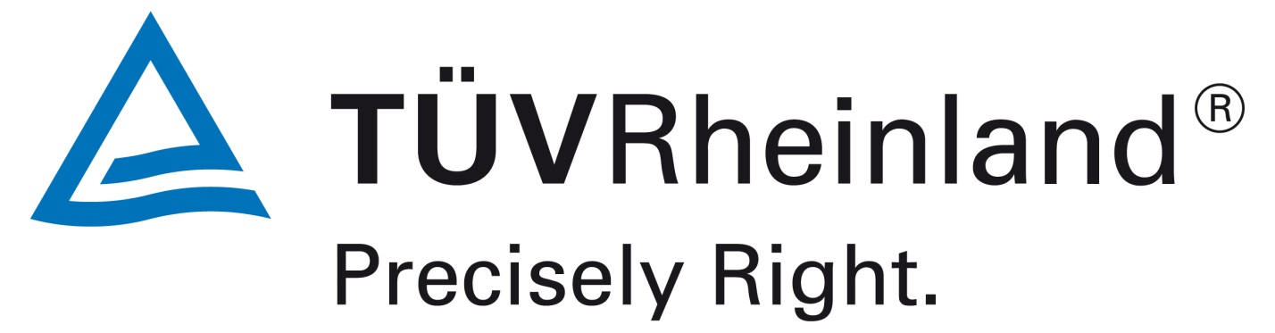

Integrity Acknowledgment

Inspector(s) / Auditor(s) Name:
Inspection/ Audit Date:
Organisation’s Name:

We hereby acknowledge the receipt of TUV Rheinland (India) Pvt Ltd.’s Integrity Compliance Handling Procedure Highlights.

We know that any employee from TUV Rheinland (India) Pvt Ltd should not ask for or imply to demand or accept any benefit offered by customer, supplier, or any party having contact with TUV Rheinland (India) Pvt Ltd, and TUV Rheinland (India) Pvt Ltd regard a facilitator, a receiver, and a giver of a bribe or benefit or benefit equally guilty through association of such transaction, and that we should not offer or imply to offer any benefit to TUV Rheinland (India) Pvt Ltd.’s employee/associates ( which term includes external partners, empanelled auditors, inspectors, etc.).

We acknowledge that upon any violation, TUV RHEINLAND (INDIA) PVT LTD will report the suspected case to the investigating authorities for investigating litigant’s legal liabilities and pursuing responsibility under the law.

We acknowledge that if we offer or imply to offer any benefit to TÜV Rheinland (India) Pvt. Ltd., employee, TÜV Rheinland (India) Pvt. Ltd., would report such case to relevant customers immediately and we should bear the loss caused if any. We confirm that we were not contacted by a consultant or have used a consultant claiming to be affiliated with TÜV Rheinland (India) Pvt. Ltd.

We have understood the contents, spirit and intent of the TUV RHEINLAND (INDIA) PVT LTD., procedure on integrity. We commit to abide by this policy and should the need arise we understand and there is channel (TÜV Rheinland (India) Pvt. Ltd. Compliance Hotline) to timely contact for the purpose of seeking clarification, providing comments or reporting Integrity issues.

We know that the acknowledgment is a contractual agreement clearly stating both parties’ (TUV RHEINLAND (INDIA) PVT LTD., and the organisation’s), responsibility to adhere to the TUV RHEINLAND (INDIA) PVT LTD., Integrity Compliance Policy. We sign our name with the Company stamp in the space provided below to acknowledge our commitment and cooperation with the TUV RHEINLAND (INDIA) PVT. LTD.’s Integrity Compliance Policy.

_________________________________ ________________________________

Print Name/ Title Signature/ Time

_________________________________ _________________________________

Office Phone Number/ Cell Phone Number Company Stamp

